EPiServer SharePoint Connector

Abstract
An increasing amount of customers want to build a solution based on EPiServer using functionality provided by Windows SharePoint Services. This white paper describes some of the possibilities that are available, the techniques that can be used, and presents a basic implementation scenario. The intention is to give the reader new ideas and to present a sample kit that could be used as a base in an EPiServer/SharePoint integration project.

Building Solutions on EPiServer and SharePoint

Intranet Requirements
A company or organisation building an intranet normally has some basic requirements. Firstly the employees should have a common place where they can find all company information and news. They need a simple, but dynamic, way to add and modify information and they want to organise the information in a structured way.
Some companies also have an extended need for workgroups to collaborate within the company, especially when it comes to sharing documents within the group.
If the company uses a Windows SharePoint Services-based (WSS) solution, it will, after a while, contain a large amount of different Web sites or “working areas”. This may result in a SharePoint user having difficulty navigating in the solution or even “getting lost”. This scenario requires a structure of all the different Web sites and an easy way of navigating between them.
Integrating EPiServer and SharePoint may introduce another user requirement – to have the possibility to also view selected information from the intranet inside the WSS part of the system.
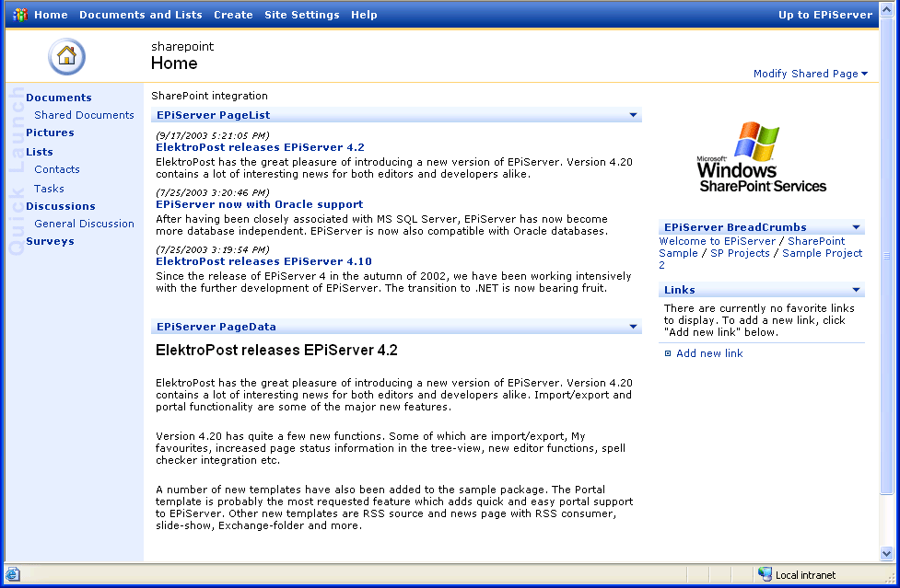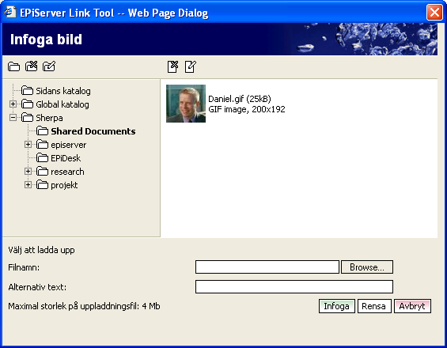

The Solution
To handle your basic intranet requirements, you would probably select a Content Management System. A Content Management System like EPiServer has long been a perfect solution to fulfil this need. All company information can be handled with its clear information structure and powerful environment for the editors.
The day-to day document handling or team collaboration could be managed by building a customised “working area” into the EPiServer solution. Another way is to add the functionality using Windows SharePoint Services. By mixing the two products, you can achieve a flexible and cost-effective solution.
To get organized in WSS you can choose to use SharePoint Portal Server. Another interesting solution is to use EPiServer to provide support for navigation and to add a structure to the sites in WSS. If you use this kind of functionality from EPiServer and provide it in SharePoint, you can really get organized.
Finally, to fulfil the need for users to see EPiServer information inside WSS you would probably add this functionality using EPiServer WebParts.

The Integration - Technical Overview
There are several ways of integrating EPiServer and SharePoint. In our Connector package we provide two separate solutions. The first solution is built on the need an EPiServer user has for content and functionality in SharePoint. We have added an SP File System and some SharePoint Integration templates into EPiServer. Data is delivered using a Web Service running under the SharePoint application. The Authentication Listener is added to make it possible to be authenticated in SharePoint using the same user identity as used in EPiServer.
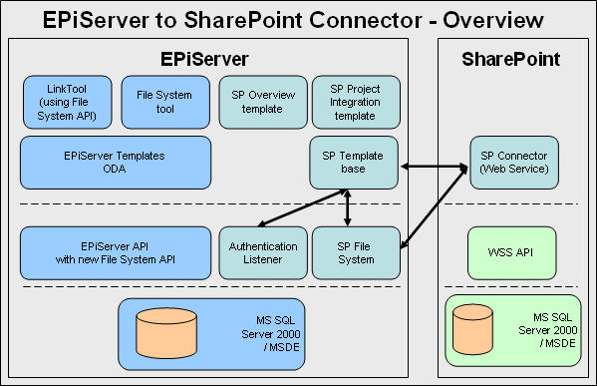
The second method we use in the SharePoint part of the sample set is by running the EPiServer SharePoint Connector (EPiServerProxy) in the same application as SharePoint. EPiServerProxy then accesses data using a Web Service. This method gives us the benefits of reaching functionality in both EPiServer and SharePoint at the same time. EPiServerProxy does not provide all functionality in EPiServer, but gives enough support to fetch data and add data to EPiServer.
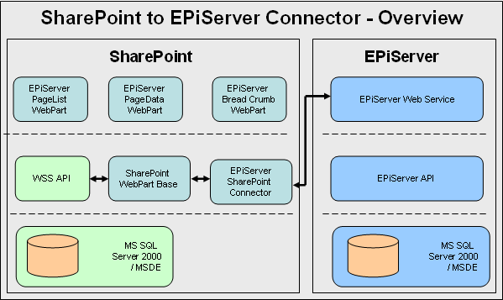

Add SharePoint Functionality to EPiServer
In the solution built on EPiServer and WSS, the users will probably use WSS to organise their documents. When the user is working in the EPiServer part of the solution, he or she can then hook in to the document store in SharePoint. Using Open Development Architecture (ODA) in EPiServer, the Link Tool can be extended. The extension will give the user a new folder choice in the Link Tool, which provides access to documents in SharePoint.
Below is a sample of the file system and Link Tool showing content from SharePoint.
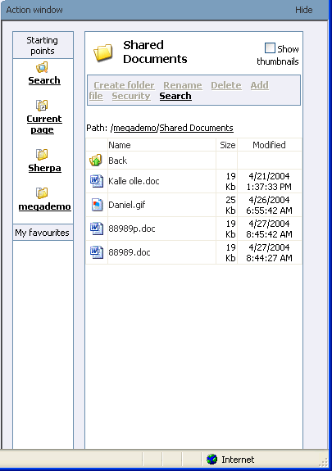

SP Overview
The sample template SP Overview in EPiServer makes it possible to obtain a structured overview over the Webs and sites in the SharePoint environment. In the sample implementation, the user can obtain a complete list of sites and he or she can also open the corresponding site (in an IFRAME) by clicking the list. The user will only see the sites he or she has access to.
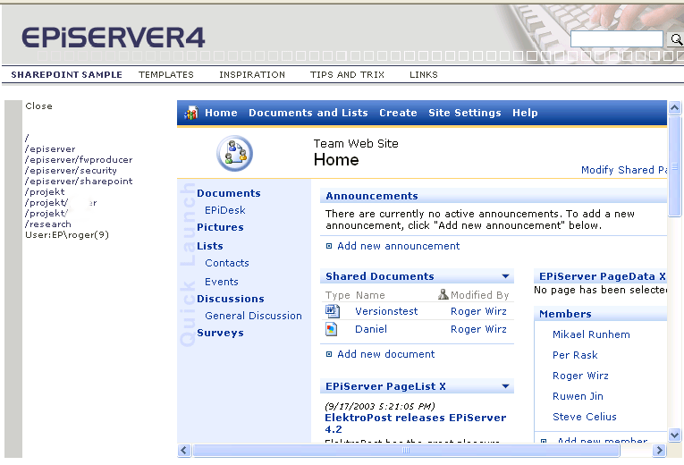

SP Integrated Project
In many cases a user needs an overview of material and information connected to a specific project. The problem is that the information can be spread around in many different systems. The sample template SP Integrated Project shows how this information can be gathered together and reached from one point.
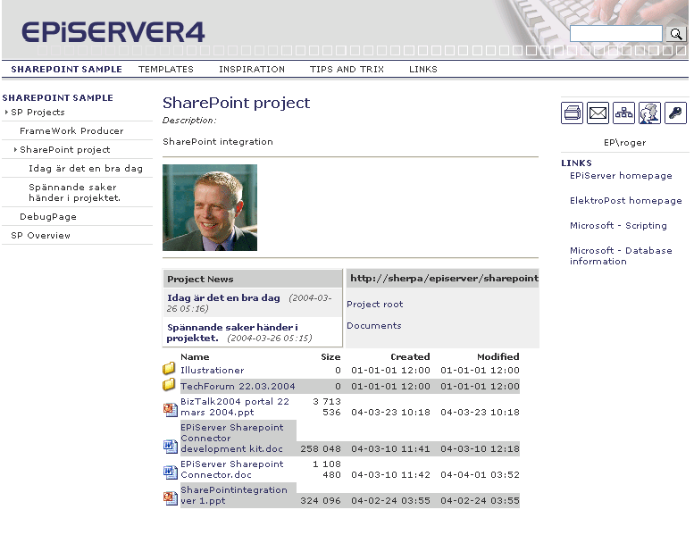
Each project is based on a page in EPiServer. When you edit the page, you can set up the site that the project is connected to and which document folder files should be listed from.
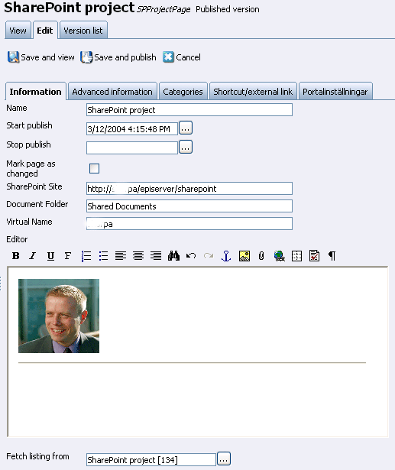

Add EPiServer Functionality to SharePoint

EPiServer WebParts
The most obvious method of adding EPiServer functionality and EPiServer content into SharePoint is by using one or more WebParts. Important information and navigation from EPiServer can be shown in the SharePoint environment.
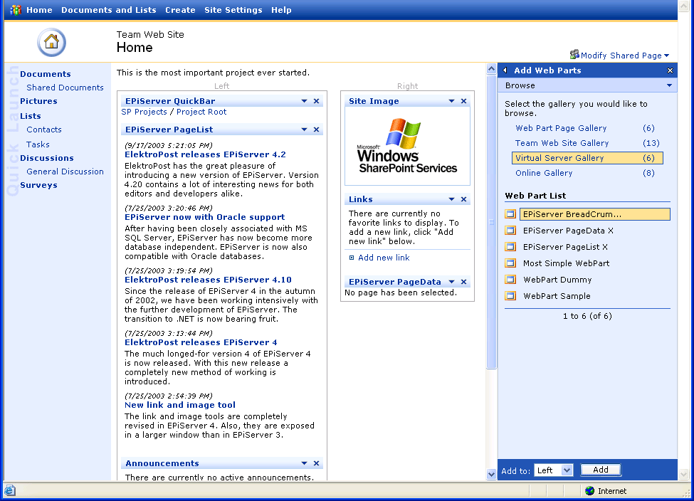
Connected to this white paper we have developed a sample set of WebParts that can provide the most common information from EPiServer. These WebParts are described below.

WebPart - EPiServer PageList
An EPiServer PageList WebPart is a WebPart that takes a given point of the structure in EPiServer and displays it as a list in SharePoint. This WebPart is a typical information viewer and shows the SharePoint user-selected information from the EPiServer-based Web. It can show all kinds of information, but will normally show news or other dynamic information.
From EPiServer PageList WebPart it is possible to connect to other WebParts (PageData and PageView), so that when a user clicks an item in the list, another WebPart will be updated to display the requested information.
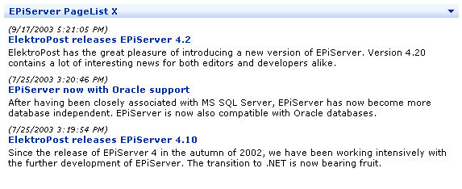

WebPart - EPiServer PageData
The EPiServer PageData WebPart will display content from a given page in EPiServer. The PageData WebPart is used when you want to use the existing design within SharePoint and only want to display the most frequently used properties (Title and MainBody) within EPiServer pages. EPiServer PageData supports Connections. See below for further information about connections.
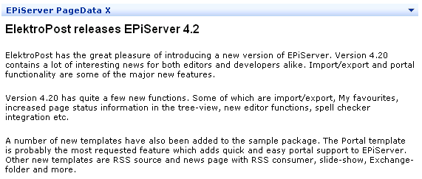

WebPart - EPiServer Bread Crumb (Site Organizer)
The EPiServer Bread Crumb WebPart is used to display SharePoint paths stored in EPiServer. Using this WebPart you can add a reference to all created SharePoint subsites into an EPiServer structure and organise them in a well-managed way. Basically, a solution built on this WebPart, together with a third-party search engine like MondoSearch, gives the customer all the support they need to create a complete EPiServer/WSS-based intranet.
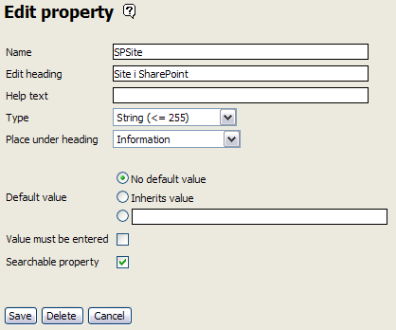
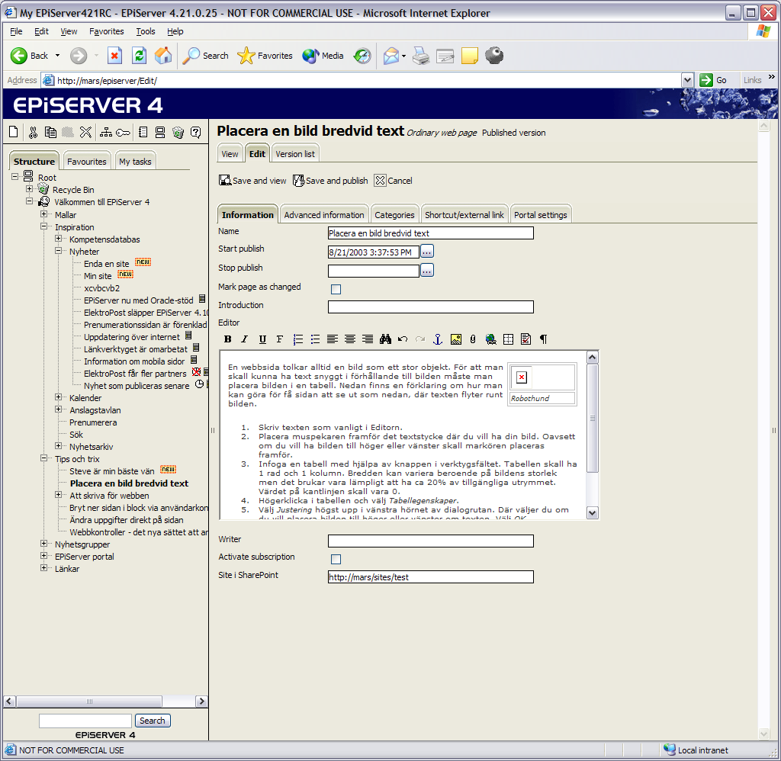
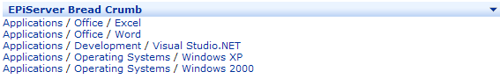

Connections
The PageList, PageData and PageView WebParts can all be connected to each other. When a user clicks a page in the PageList, a PageData should be updated to show the content of the page. This built-in functionality in SharePoint works very well when implementing EPiServer functionality in to SharePoint.
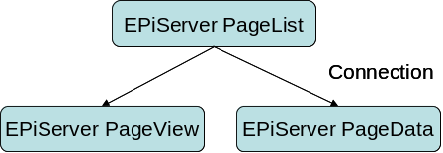
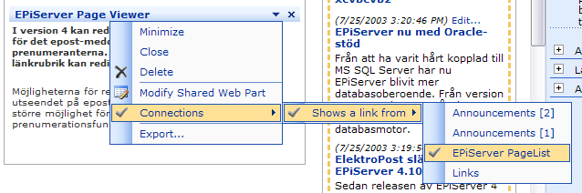
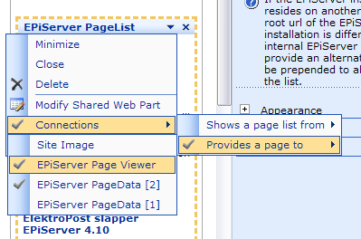

Searchability
Centralised search functionality is not included in the samples provided. Windows SharePoint Services does not provide search support, which makes it harder to provide one integrated search function. By using SharePoint Portal Server, you can set up search functions based on crawler functionality and this should make it possible to also include content from EPiServer WebParts. Another solution is to use a third-party product like MondoSearch from Mondosoft.
All content in EPiServer is always searchable, which makes it easy to create a search function that searches EPiServer content.

Authentication
The solution described in this white paper is based on a scenario where EPiServer runs under WSS. The easiest way to set up the authentication mechanism is to use Windows Authentication on the site.
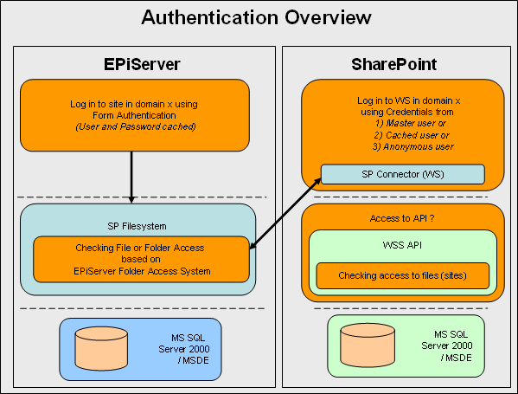
In the web.config file in the EPiServer application, it is possible to add a “master user”. This account is used if the SP File System should display all Virtual Servers on the WSS. If only one specific Virtual Server will be accessed, the account will not be necessary.

The Next Step
Together with this white paper there are some samples that could be used as a platform for developers building EPiServer/SharePoint integration. The best next step to take is to gain access to the samples and see the possibilities that they reveal.

